ARRAY AND POINTER
1.CODE
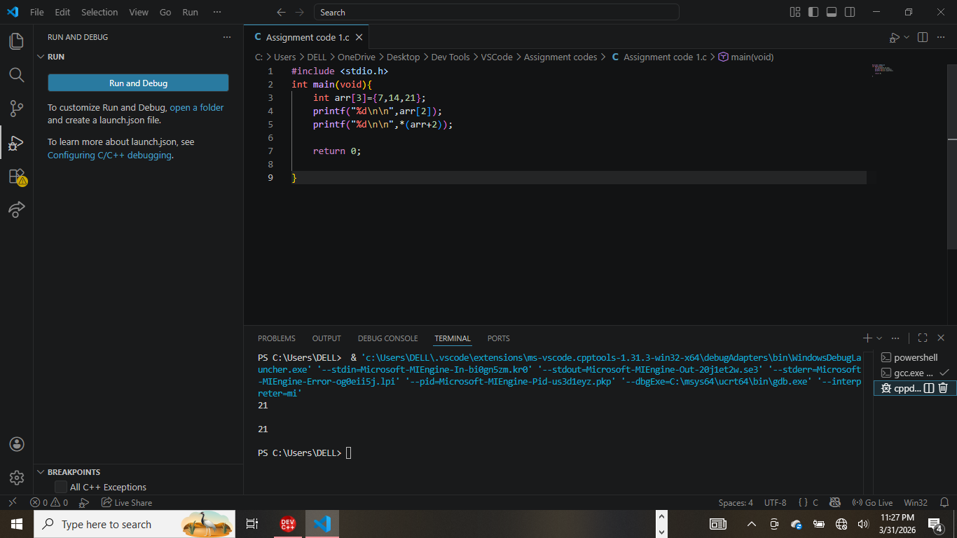

This C program demonstrates that accessing an array element using standard indexing (e.g., `arr[2]`) is functionally identical to accessing it using pointer arithmetic (e.g., `*(arr+2)`).

Step-by-Step Breakdown

1. `int arr[3]={7,14,21};`
This line initializes an integer array named `arr` with three values.
Index 0 holds `7`.
Index 1 holds `14`.
Index 2 holds `21`.

2. `printf("%d\n\n",arr[2]);`
This prints the value at index 2 using standard array notation.
Output: 21

3. `printf("%d\n\n",*(arr+2));`
This prints the same value using pointer arithmetic.
`arr` represents the memory address of the first element.
`+2` moves the pointer forward by two integer positions (to the third element).
`*` (the dereference operator) retrieves the value stored at that new address.
Output: 21

2.CODE 2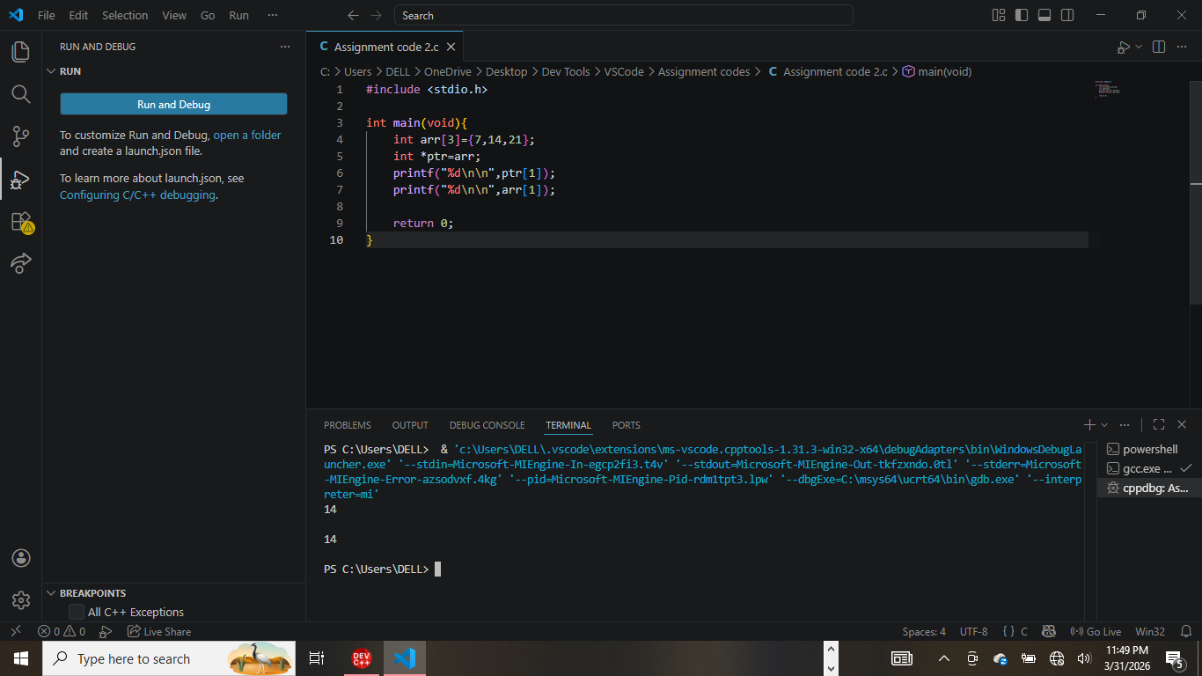

This C program demonstrates that a pointer assigned to an array can be used with array subscript notation (square brackets) to access elements, just like the array name itself.

Step-by-Step Breakdown

1. `int arr[3]={7,14,21};`
Initializes an integer array named `arr` containing the values 7, 14, and 21.

2. `int *ptr=arr;`
Declares an integer pointer named `ptr`.
Assigns the address of the array `arr` to `ptr`. In C, the name of an array acts as a pointer to its first element. Therefore, `ptr` now points to the value `7`.

3. `printf("%d\n\n",ptr[1]);`
Accesses the element at index 1 using the pointer variable `ptr`. Even though `ptr` is a pointer, C allows you to use array syntax (`[]`) on it.
Output: 14

4. `printf("%d\n\n",arr[1]);`
Accesses the element at index 1 using the standard array name `arr`.
Output: 14

3.CODE 3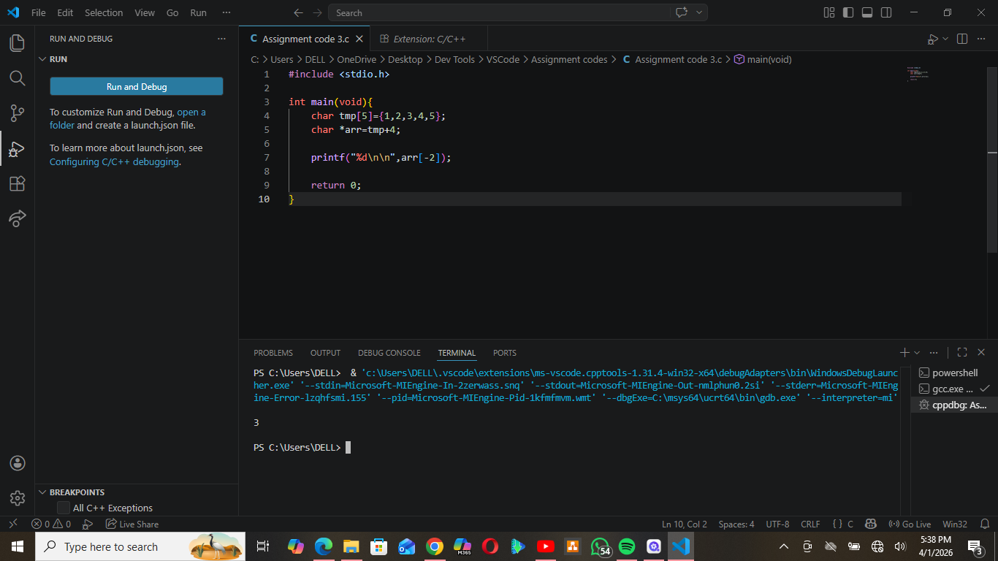

This C program demonstrates how pointer arithmetic allows you to access array elements relative to a specific position, including using negative indices to look "backwards" in memory.

Step-by-Step Breakdown

1. `char tmp[5]={1,2,3,4,5};`
Initializes a character array named `tmp` with the integer values 1, 2, 3, 4, and 5.
Index 0 holds `1`, Index 1 holds `2`, ..., Index 4 holds `5`.

2. `char *arr=tmp+4;`
Declares a pointer named `arr`.
Instead of pointing to the start of the array, `tmp+4` sets the pointer to the **last element** (Index 4, which holds the value `5`).

3. `printf("%d\n\n",arr[-2]);`
This line uses a negative index: `arr[-2]`.
* Since `arr` is currently pointing at Index 4, asking for `[-2]` tells the program to move **2 positions backward** from the current pointer location.
* Calculation: Index 4 minus 2 equals **Index 2**.
* The value at Index 2 is `3`.

4. CODE 4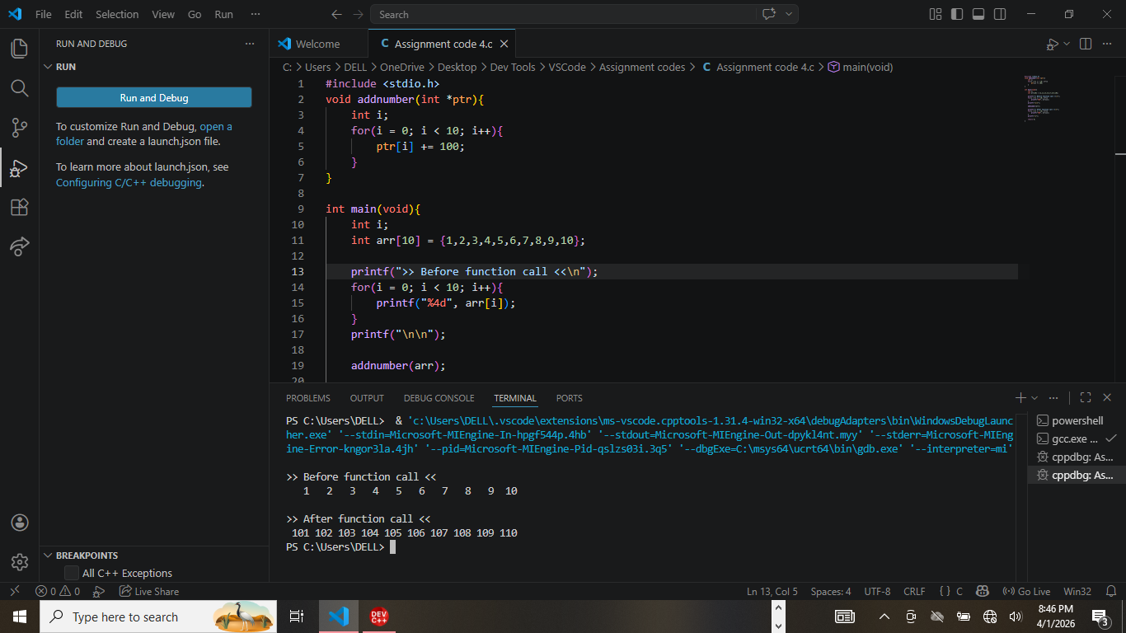

This C program demonstrates that when an array is passed to a function, the function receives a reference (pointer) to the original data. This allows the function to modify the actual values in the array, rather than working on a copy.

**Step-by-Step Breakdown**

1. **`void addnumber(int *ptr)`**
* This function accepts an integer pointer `ptr` as an argument.
* Inside the function, a `for` loop iterates from index 0 to 9.
* **`ptr[i] += 100;`**: This line adds 100 to every single element in the array. Because `ptr` points to the original array's memory location, these changes are permanent.

2. **`int arr[10] = {1,2,3,4,5,6,7,8,9,10};`**
* In `main`, an array of 10 integers is initialized with values 1 through 10.

3. **`printf(">> Before function call <<\n");`**
* The program prints the original values: **1 2 3 4 5 6 7 8 9 10**.

4. **`addnumber(arr);`**
* The array is passed to the function. The function executes, adding 100 to every number.

5. **Output After Function Call**
* Although the printing code for the "After" section is partially cut off in the editor view, the terminal output at the bottom shows the result: **101 102 103 104 105 106 107 108 109 110**.

FUNCTION POINTER

5. CODE 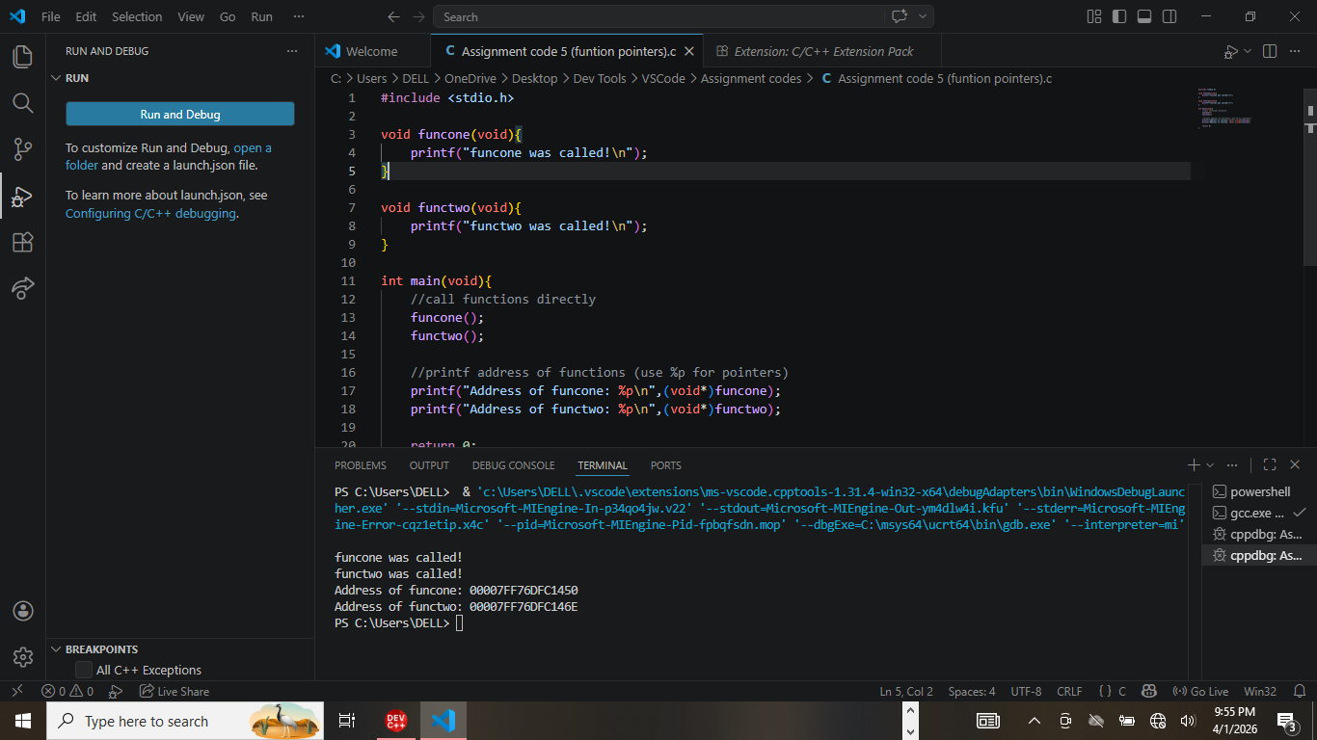

This C program demonstrates that functions, like variables, are stored at specific locations in the computer's memory. It shows how to call functions normally and how to retrieve/print their memory addresses.

**Step-by-Step Breakdown**

1. **Function Definitions (`funcone` and `functwo`)**
* Two simple functions are defined. Each takes no arguments (`void`) and returns nothing (`void`).
* Their only job is to print a message to the screen indicating they have been executed.

2. **Direct Function Calls**
* Inside `main`, the code calls `funcone();` and `functwo();`.
* This executes the code inside those functions, printing "funcone was called!" and "functwo was called!".

3. **Printing Function Addresses**
* **`printf("Address of funcone: %p\n", (void*)funcone);`**
* In C, the name of a function (e.g., `funcone`) acts as a pointer to the memory address where that function's code begins.
* The code casts the function name to a generic pointer `(void*)` so it can be printed using the `%p` format specifier (which is used for printing memory addresses in hexadecimal).

6.CODE 6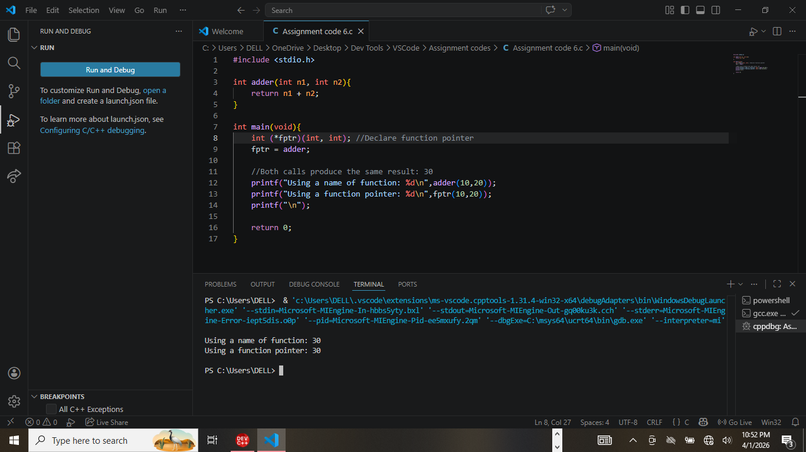

This C program demonstrates how to create and use a "function pointer." A function pointer is a variable that stores the memory address of a function, allowing you to call that function indirectly through the pointer variable.

**Step-by-Step Breakdown**

1. **`int adder(int n1, int n2)`**
* A standard function is defined that takes two integers as input and returns their sum.

2. **`int (*fptr)(int, int);`**
* This line declares a function pointer named `fptr`.
* The syntax specifies that `fptr` can only point to functions that take two `int` arguments and return an `int`.

3. **`fptr = adder;`**
* The pointer `fptr` is assigned the address of the `adder` function. Now, `fptr` acts as an alias or reference to the `adder` function.

4. **Calling the Function**
* **Direct Call:** `adder(10, 20)` calls the function using its original name.
* **Pointer Call:** `fptr(10, 20)` calls the function using the pointer variable.

7.CODE 7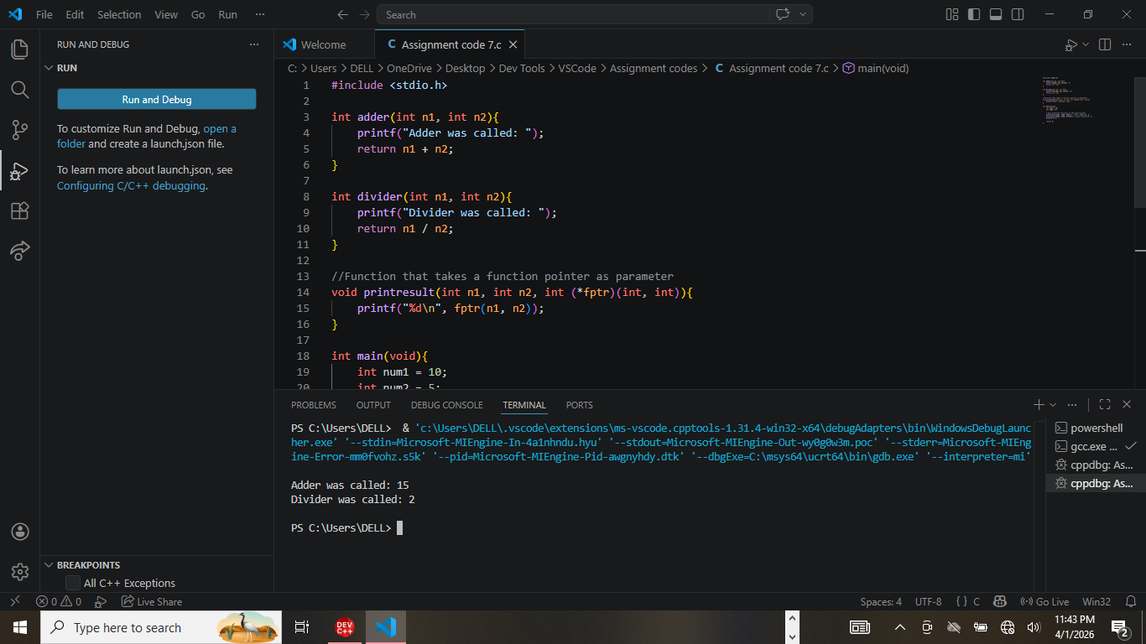

This C program demonstrates a powerful feature called "higher-order functions." It shows how to pass a function pointer as an argument to another function. This allows a single function (`printresult`) to perform different operations depending on which function is passed to it.

**Step-by-Step Breakdown**

1. **`adder` and `divider` Functions**
* Two standard functions are defined. Both take two integers as arguments.
* `adder` returns the sum (`n1 + n2`).
* `divider` returns the quotient (`n1 / n2`).
* Both functions also print a message indicating which one was executed.

2. **`printresult` Function**
* This function is designed to be generic. It takes three parameters: two integers (`n1`, `n2`) and a function pointer (`int (*fptr)(int, int)`).
* Instead of doing math itself, it calls the function passed to it via `fptr(n1, n2)` and prints the result.

3. **`main` Function Execution**
* Although the specific calls in `main` are partially cut off at the bottom, the logic (and the terminal output) reveals what happened:
* **First Call:** `printresult` was called with the `adder` function passed as the argument. It executed `10 + 5`, printing "Adder was called: 15".
* **Second Call:** `printresult` was called again, but this time with the `divider` function passed as the argument. It executed `10 / 5`, printing "Divider was called: 2".

8. CODE 8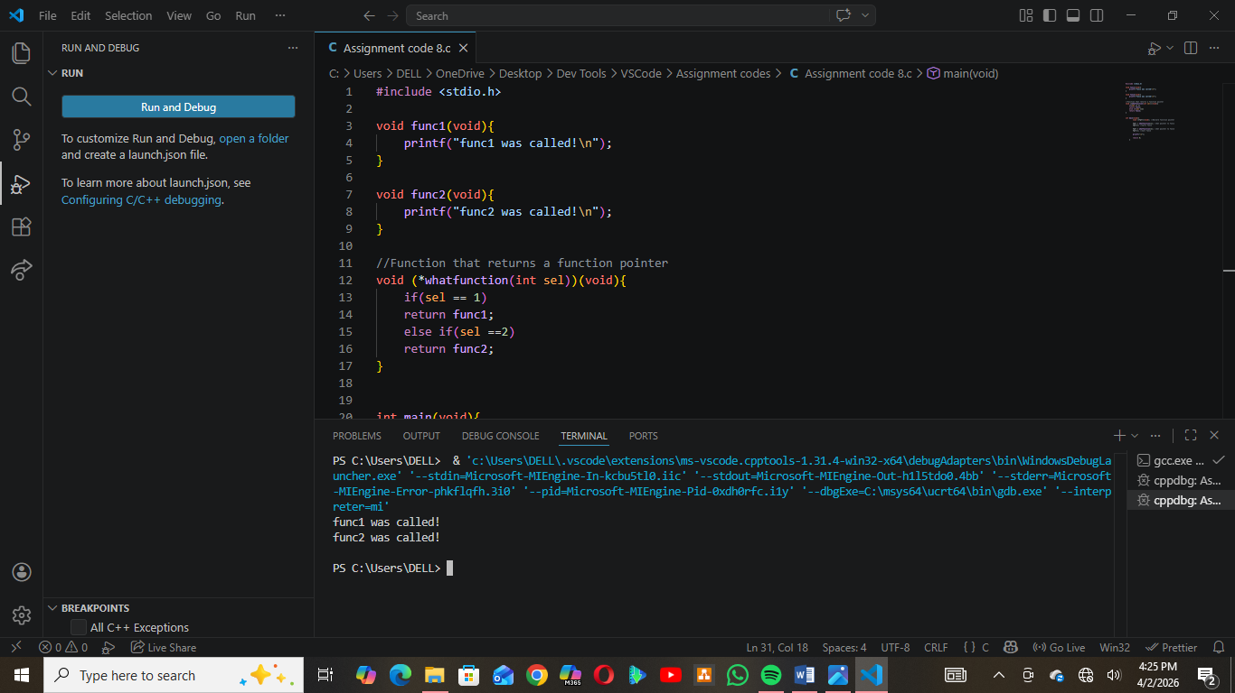

This C program demonstrates a more advanced concept where a function (`whatfunction`) does not return a number or a character, but instead returns a **pointer to another function**. This allows the program to dynamically select which function to run based on an input value.

**Step-by-Step Breakdown**

1. **`func1` and `func2`**
* Two simple functions are defined. Both take no arguments (`void`) and return nothing (`void`).
* Their only purpose is to print a specific message to the screen ("func1 was called!" or "func2 was called!").

2. **`whatfunction(int sel)`**
* This is the core of the program. Its complex signature `void (*whatfunction(int sel))(void)` means:
* It takes an integer argument named `sel` (selector).
* It **returns** a pointer to a function that takes no arguments and returns nothing.
* **Logic:**
* If `sel` is **1**, it returns the address of `func1`.
* If `sel` is **2**, it returns the address of `func2`.

3. **Execution (Inferred from Terminal)**
* Although the `main` function is cut off at the bottom of the editor, the terminal output shows that the program successfully called `whatfunction`.
* It likely called the returned function immediately (e.g., `whatfunction(1)()`), which retrieved `func1` and executed it.
* It then did the same for selection 2, retrieving and executing `func2`.

